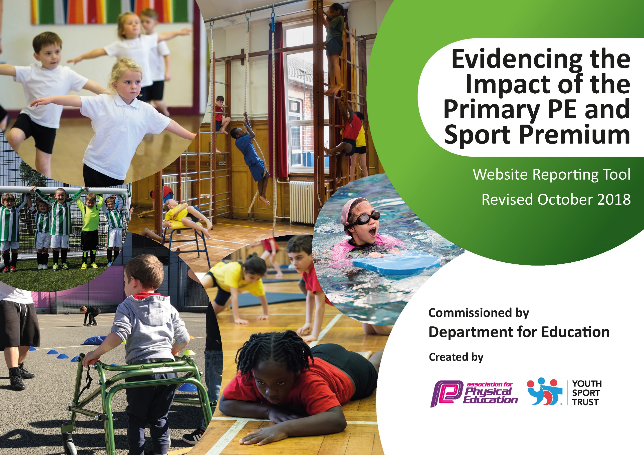
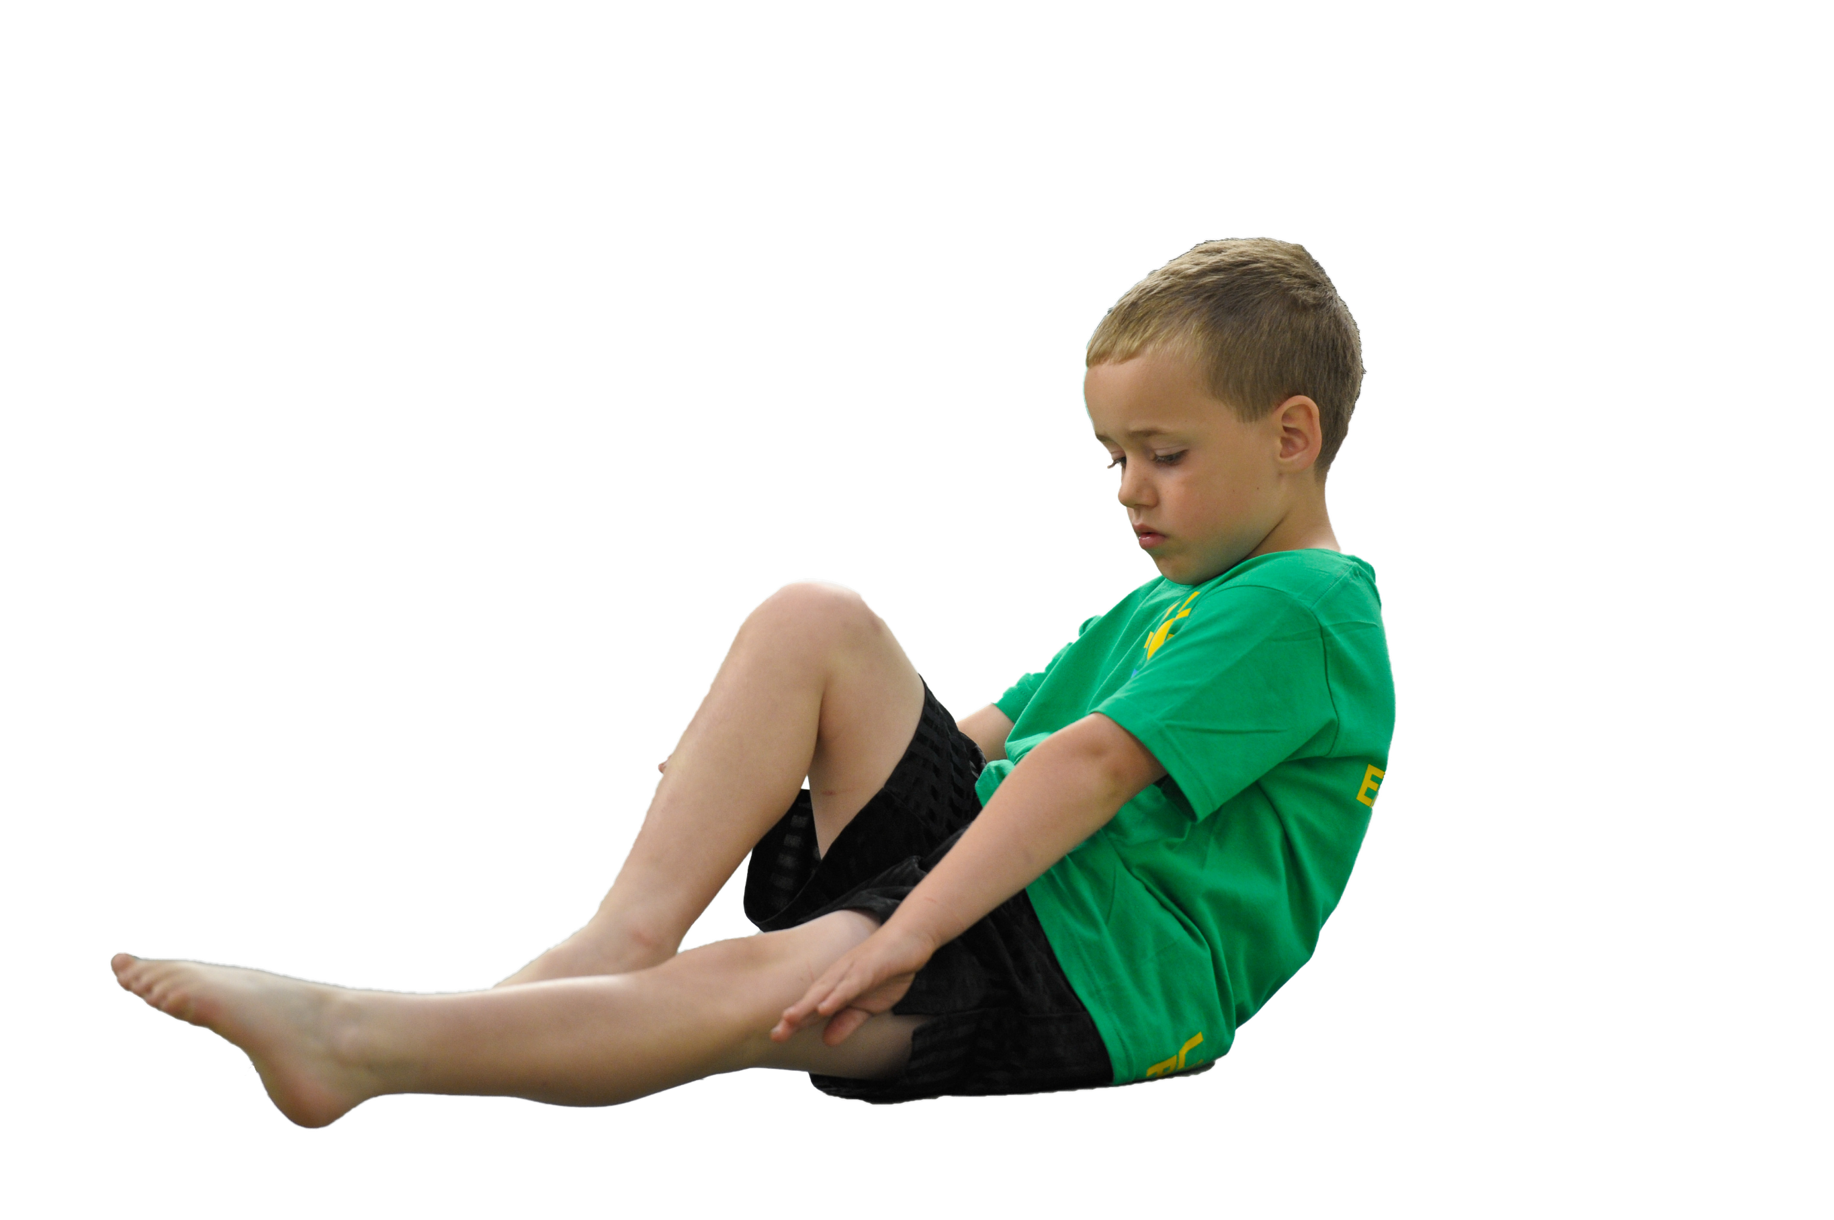
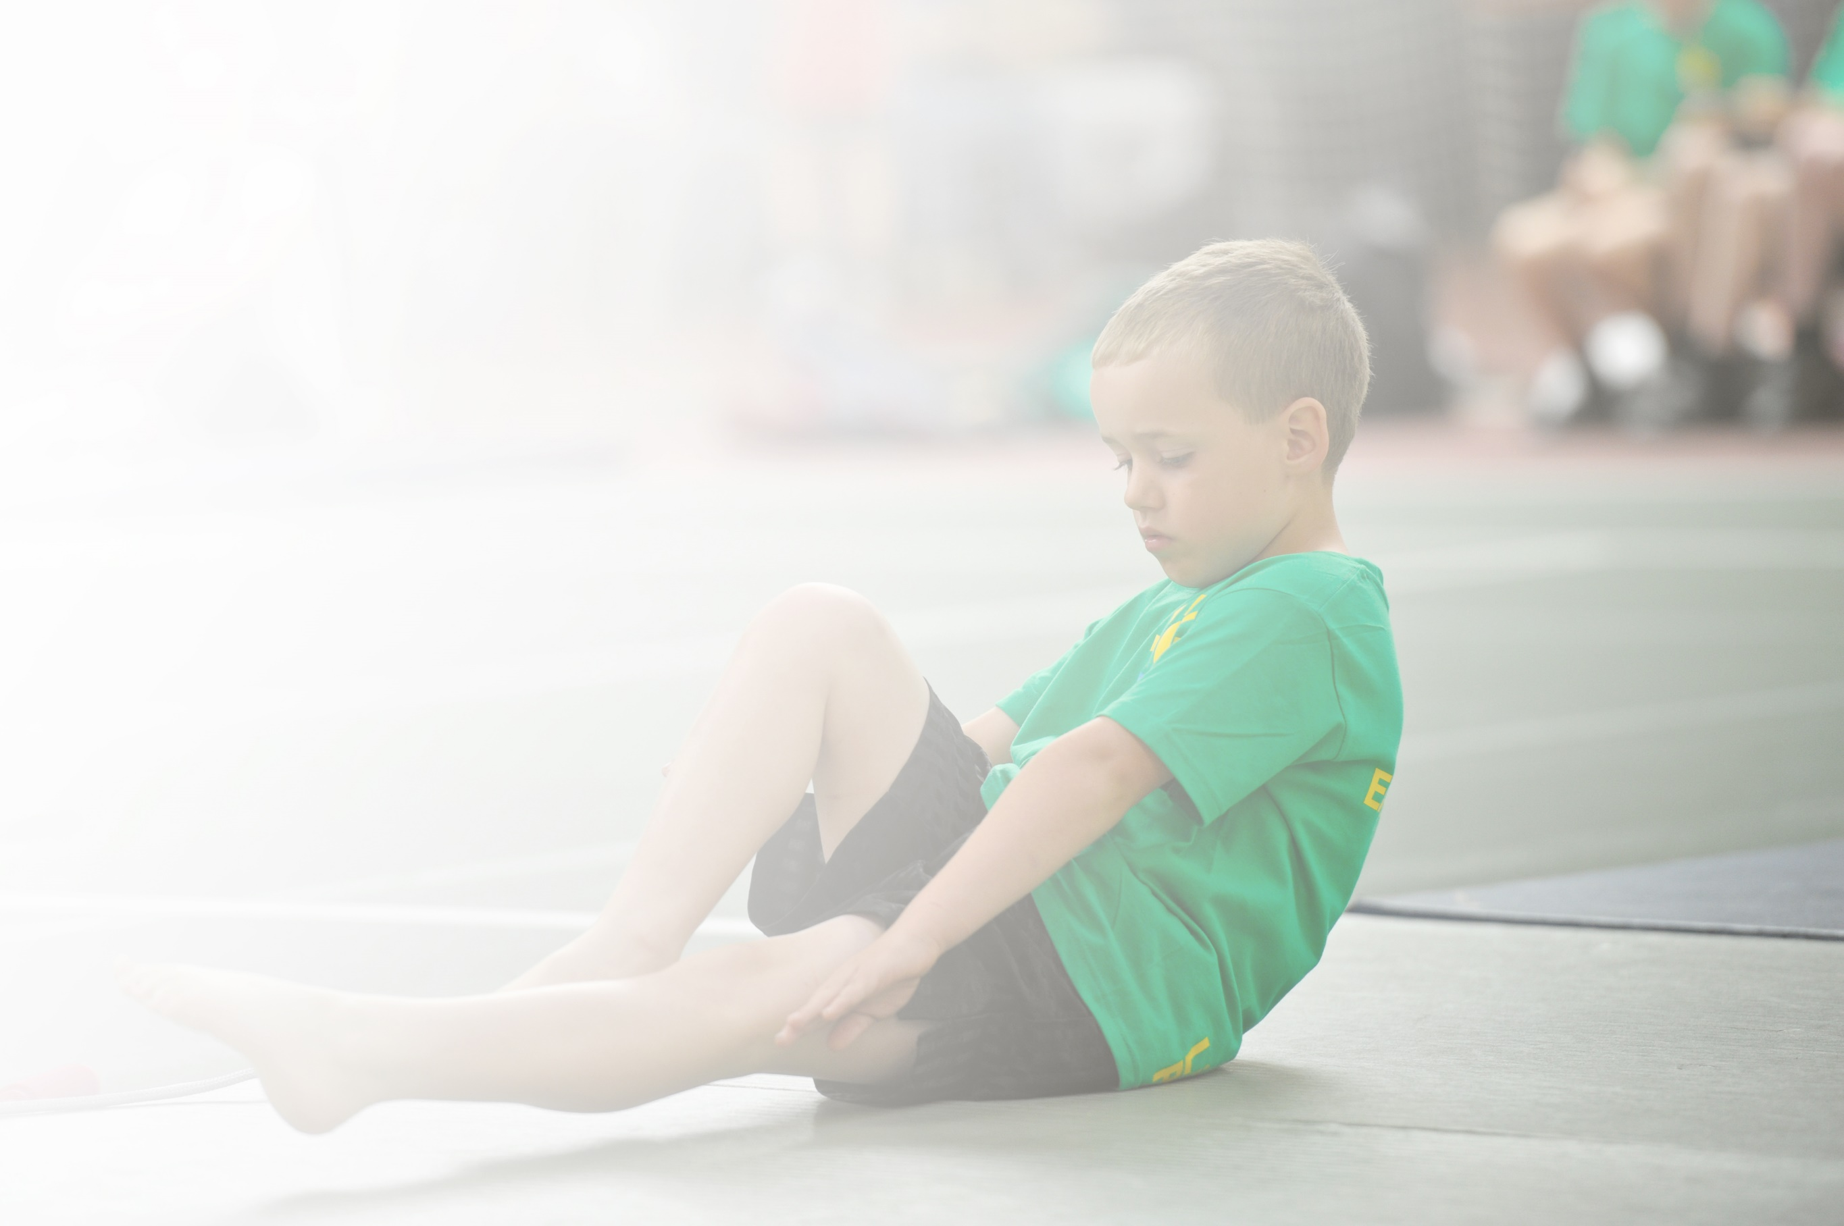
Schools must use the funding to make additional and sustainable improvements to the quality of Physical Education, Sport and Physical Activity (PESPA) they offer. This means that you should use the Primary PE and Sport Premium to:

- Develop or add to the PESPA activities that your school already offer
- Build capacity and capability within the school to ensure that improvements made now will benefit pupils joining the school in future years

Please visit gov.uk for the revised DfE guidance including the 5 key indicators across which schools should demonstrate an improvement. This document will help you to review your provision and to report
your spend. DfE encourages schools to use this template as an effective way of meeting the reporting requirements of the Primary PE and Sport Premium.

We recommend you start by reflecting on the impact of current provision and reviewing the previous
spend. Under the Ofsted Schools Inspection Framework, inspectors will assess how effectively leaders use the Primary PE and Sport Premium and measure its impact on outcomes for pupils, and how effectively governors hold them to account for this.

Schools are required to publish details of how they spend this funding as well as on the impact it has on pupils’ PE and sport participation and attainment by the end of the summer term or by 31 July 2022 at the
latest.
We recommend regularly updating the table and publishing it
on your website throughout the year, as evidence of your
ongoing review into how you are using the money to
secure maximum, sustainable impact. To see an
example of how to complete the table please
click HERE.

Support for review and reflection - considering the 5 key indicators from DfE, what development needs are a priority for your setting and your students now and why? Use the space below to reflect on previous spend, identify current need and priorities for the future.

Key achievements to date: | Next year’s targets:
- Over 80% of the children in school taking part in after school clubs for the last 5 years.  - 100% of Key Stage 2 taking part in level 1 competitions.  - 56% of the school and 73% of Key Stage 2 taking part in a level 2 competition.  - A range of coaches coming into school teaching lessons and working with teachers to upskill staff.  - A range of courses attended by staff in areas highlighted as weak points in staff confidence.  - Lancashire scheme of work acquired for early years, key stage 1 and key stage 2 to help teachers confidently deliver P.E. lessons covering national curriculum objectives.  - Success in a number of sports across a number of year groups in level 2 competitions including representatives at the Lancashire School Games.  - Gold achieved in the School Games Mark regularly.  - An area of the playground that was previously unusable has been transformed into a climbing section for children to play on.  - At dinnertimes, a member of staff from Sportscool has been on the playground encouraging the children to take part in sporting activities during their break time.  - One staff meeting every few months has a P.E. focus where staff can be kept up to date with any changes, share ideas and ask any questions.  - Each P.E. lesson in Year 5 started with a personal challenge to see if this increased children’s motivation in lessons. This trial was successful.  - A ‘Sporting Hero’ award to be given every half term to one student who has stood out in P.E. lessons or extra curricular activities. The student has their picture on the P.E. display board and is given a trophy to keep.  - Regular assemblies discussing the benefits of exercise and sport and discussing ways to get more children participating in physical activity.  - A trophy given in the end of year assembly to a year 6 student who has shone in sport throughout their time at Stubbins.  - A school sports crew made up of Year 5 students helps with practising and picking a team for a few level 2 competitions each year.  - 2021/2022 – 89% of Key Stage 2 took part in after school activities.  - 2021/2022 – 93% of Key Stage 2 took part in a sports competition.  - As a school, we attended more competitions than any other school in Rossendale. | - All students to engage in the recommended 30 minutes of physical exercise each day.  - All classes to have a focus on a personal challenge.  - Year 5 and 6 children training younger children in school before a competition.  - Encourage more KS1 children to be physically active.  - Experiment with new after school clubs to try and encourager even more children to take part. (Ultimate Frisbee, Tag Rugby and couch to 5k to be trialed).

Action Plan and Budget Tracking
Capture your intended annual spend against the 5 key indicators. Clarify the success criteria and evidence of impact that you intend to measure to evaluate for students today and for the future.

Academic Year: 2021/2022 | Total fund allocated: £17,790 | Date Updated:
Key indicator 1: The engagement of all pupils in regular physical activity – Chief Medical Officer guidelines recommend that primary school children undertake at least 30 minutes of physical activity a day in school |  |  |  | Percentage of total allocation:
 |  |  |  | %
School focus with clarity on intended impact on pupils: | Actions to achieve: | Funding allocated: | Evidence and impact: | Sustainability and suggested next steps:
A member of staff from Sportscool to come to school each dinnertime with the aim of getting as many children as possible to take part in physical activity at dinnertime.  Increase physical activity on the infant playground. | Sportscool staff to encourage children who are not getting involved to participate. Sportscool member of staff should also referee games and help manage arguments so more children will get involved.  Improve facilities on the infant playground to encourage more children to keep active. | £8976.45  £3,516.57 | Over the last few years, Sportscool have had an impact on getting more children active at playtimes but the effect of this hasn’t been as great as it has been in previous years. Therefore, this will be the last year that Sportscool are in running clubs at dinner times.  Infant playground to be improved with more choice of activities at playtimes. | Think carefully about how to encourage more children to be active throughout their dinner times and playtimes.  More children will be active and this will help to get them into good habits of staying active and healthy at playtimes.
Key indicator 2: The profile of PESSPA being raised across the school as a tool for whole school improvement |  |  |  | Percentage of total allocation:
 |  |  |  | %
School focus with clarity on intended impact on pupils: | Actions to achieve: | Funding allocated: | Evidence and impact: | Sustainability and suggested next steps:
A staff meeting dedicated to P.E. a few times throughout the year.  Sporting achievements are recognised and shared at end of week assemblies where children are given any certificates and medals.  A school sport Twitter account is updated regularly with information about competitions and pictures of children taking part are shared. | Allow staff to share best practise and discuss any changes or share information from training courses. |  | Staff to be more confident in delivery of P.E. lessons. | This to carry on every year.

Key indicator 3: Increased confidence, knowledge and skills of all staff in teaching PE and sport |  |  |  | Percentage of total allocation:
 |  |  |  | %
School focus with clarity on intended  impact on pupils: | Actions to achieve: | Funding  allocated: | Evidence and impact: | Sustainability and suggested  next steps:
Staff to increase their confidence in delivery of P.E. | Staff to observe experienced coaches and specialists in P.E. throughout the year in teaching a range of sports and curriculum P.E. subjects. | £4,980 | All staff have observed coaches throughout the year and make notes in sessions. This then helps staff when they are delivering their own P.E. lessons. | Staff to use what they have learnt from observations to deliver all of their own P.E. in the future. Perhaps look at reducing the coaching hours in school and when coaches are in ensure this is a team teaching exercise so teachers are fully involved in the lesson and evaluation of the lesson.u
Key indicator 4: Broader experience of a range of sports and activities offered to all pupils |  |  |  | Percentage of total allocation:
 |  |  |  | %
School focus with clarity on intended  impact on pupils: | Actions to achieve: | Funding  allocated: | Evidence and impact: | Sustainability and suggested  next steps:
Introduce children, particularly children who are not generally active, to take part in sport or physical activity.  Try some new sports to try and increase engagement for next year. We have bought equipment for an ultimate Frisbee and tag rugby club.  Ensure all gymnastics equipment is safe for lessons. | Offer a range of sports in P.E. and offer a range of afterschool clubs and competitions to introduce as many students as possible to different sports.  An even higher percentage of children taking part in after school clubs.  All equipment to be serviced so it is safe to use. | £4,980 as listed above.  Also teachers time after school to offer clubs.  £133  £184 | Teachers and Sportscool staff currently run afterschool clubs. Generally there are 6 different afterschool clubs running in school throughout the week.  Both of these clubs were trialed in P.E. lessons and feedback from children was good with lots saying they would definitely attend an after school club for these sports.  Equipment is safe to use for all classes. | Children who have not taken part have been asked which sports they would like to do. Children have said they would love a matball and shuffleball club so these will be running next year.  Run a club concentrating on these sports and if it is popular continue it each year.  Equipment will be safe to use for all P.E. lessons.
Key indicator 5: Increased participation in competitive sport |  |  |  | Percentage of total allocation:
 |  |  |  | %
School focus with clarity on intended  impact on pupils: | Actions to achieve: | Funding  allocated: | Evidence and impact: | Sustainability and suggested  next steps:
Give every child in Key Stage 2 the opportunity to take part in competitive sport. | Enter as many competitions as possible throughout the year and organise competitive fixtures with other schools. | £4,980 as listed above. | 100% of Key Stage 2 have taken part in a level 1 competition in school and 73% of Key Stage 2 have taken part in a level 2 competition. | Children who haven’t competed have been asked what we could do to help them take part more next year and these children will be targeted next year.  Next step is to try and increase number of children in Key Stage 1 to compete.

