






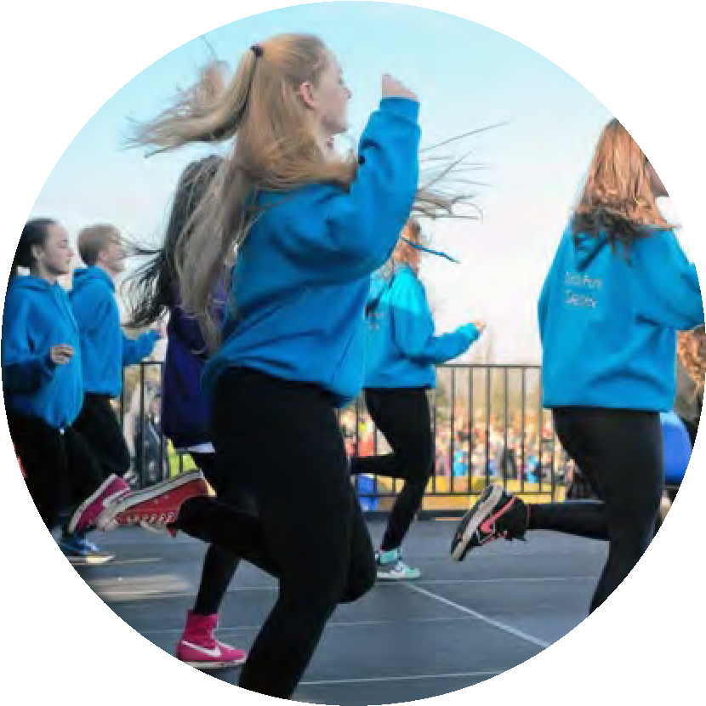
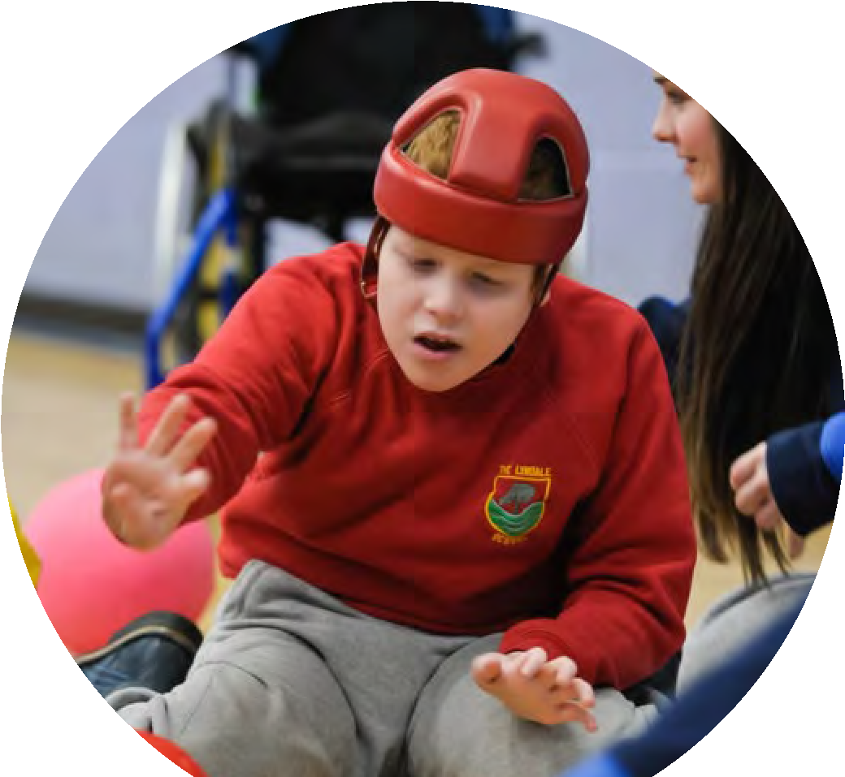
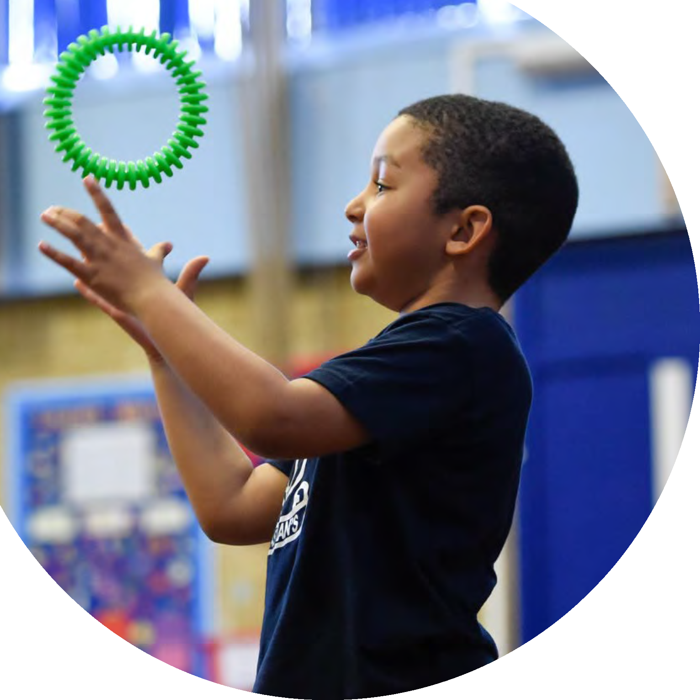


Updated September 2023
Planning, reporting and
evaluating website tool

The Primary
PE and sport
premium

Created by
Commissioned by

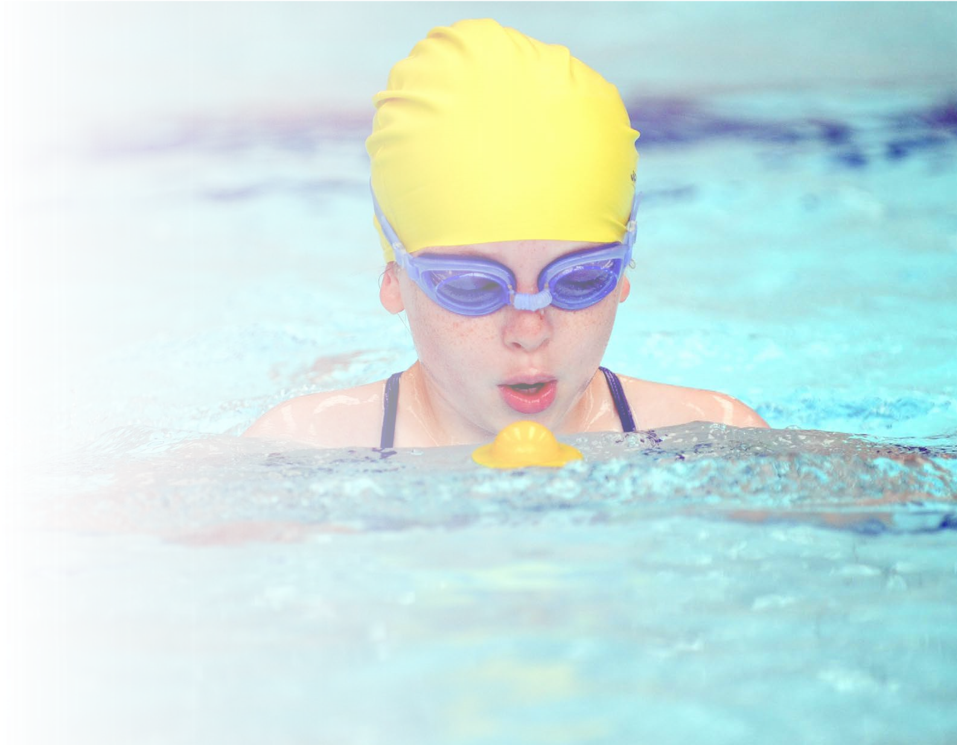
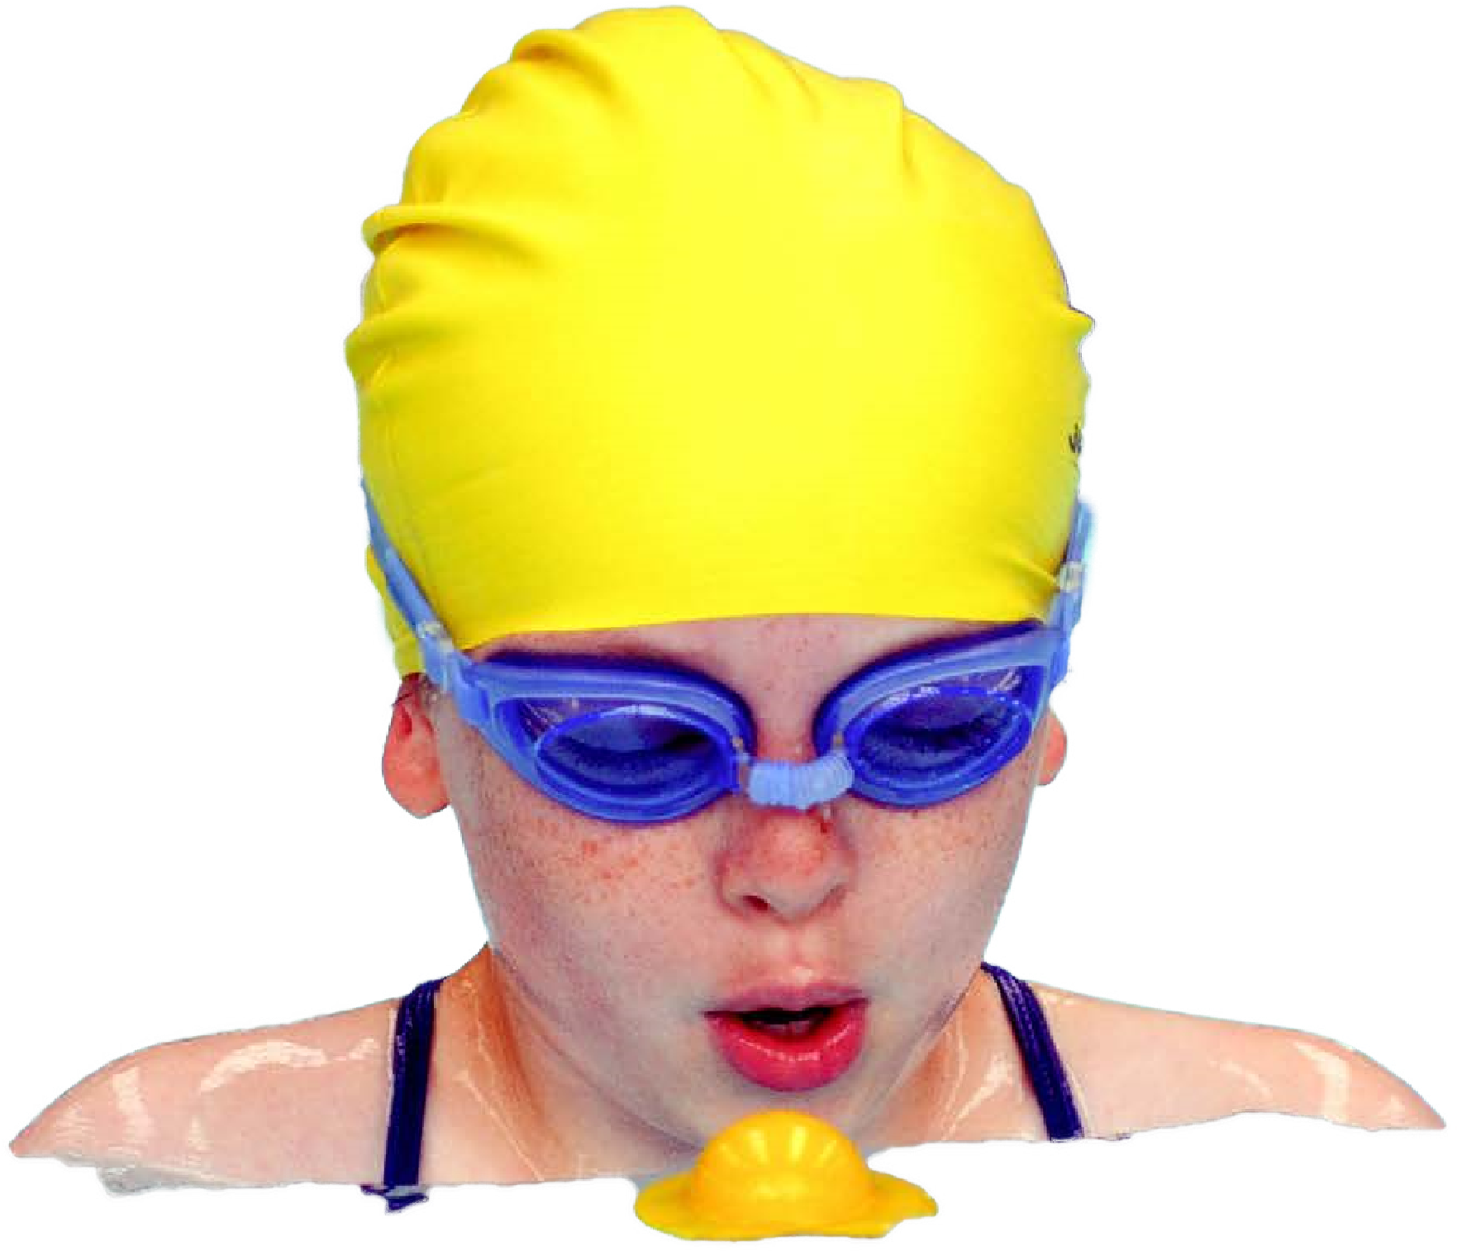
school need. necessary that spending has to meet all the key priorities, you should select the priorities that you aim to use any funding towards.
This template can be used for multiple purposes:
•

It enables schools to effectively plan their use of the
Primary PE and sport premium
•

It helps schools to meet the requirements (as set out
in guidance) to publish information on their Primary
PE and sport premium
•

It will be an effective document to support Ofsted
inspections enabling schools to evidence progress
in Physical Education (PE) and evidence swimming
attainment, which forms part of the PE National
Curriculum. We would recommend schools consider
the Intent, Implementation and Impact of any spend, as
examined within the Education Inspection Framework.

It is important that your grant is used effectively and based on
Schools must use the funding to
make
additional and sustainable
improvements
to the quality of the PE,
School Sport and Physical Activity (PESSPA)
they offer. This means that you should use the Primary PE and sport premium to:
•

Build capacity and capability within the school to ensure that improvements made now will benefit pupils joining the
school in future years
•

Develop or add to the PESSPA activities that your school already offers.

The Primary PE and sport premium should not be used to fund capital spend projects; the school’s core budget should fund
these. Further detail on capital expenditure can be found in the updated
Primary PE and sport premium guidanc
e
.
The Primary PE and sport premium guidance, outlines 5 key priorities that funding should be used towards. It is not
Although completing this template is not a requirement for schools, schools are required to publish details of how they spend this funding. Schools must also outline what the impact this funding has had on pupils’ PE and sport participation and attainment and how any spending will be sustainable in the future. All funding must be spent by 31st July 2024.
The Department for Education has worked closely with the Association for Physical Education (afPE) and the Youth Sport Trust (YST) to develop this template and encourages schools to use it. This template is an effective way of meeting the reporting requirements of the Primary PE and sport premium.
Key indicators:
Key indicator 1: The engagement of all pupils in regular physical activity – Chief Medical Officers guidelines recommend that primary school pupils undertake at least 30 minutes of physical activity a day in school
Key indicator 2: The profile of PESSPA being raised across the school as a tool for whole school improvement
Key indicator 3: Increased confidence, knowledge and skills of all staff in teaching PE and sport
Key indicator 4: Broader experience of a range of sports and activities offered to all pupils
Key indicator 5: Increased participation in competitive sport

Review of last year’s spend and key achievements (2022/2023)
We recommend you start by reflecting on the impact of current provision and reviewing your previous spend.
Activity/Action  Least active children in school to be targeted at dinner times and encouraged to take part in physical activities.  Offer more opportunities for all children to be physically active and improve their fundamental movement skills.  Increase the activity levels of children in subjects throughout the curriculum.  Lancashire P.E. Passport app to be used throughout school for planning and assessment.  Increase the number of children throughout school taking part in extra-curricular sports.  Offer more opportunities for all children to be physically active and improve their fundamental movement skills. | Impact  More children were taking part in activities at dinnertimes than they were previously.  New equipment was purchased for P.E. lessons and break times which is being used throughout school.  Children are on the whole being more active in lessons and physical activity during lessons is regularly mentioned in staff meetings.  Planning and delivery of P.E. lessons throughout school is now much more consistent and plans build on skills more effectively from year to year.  Every child in Key Stage 2 took part in an extra-curricular sports activity (including dinner times)  New equipment was ordered for Key Stage 1 and Key Stage 2 which allows children to play and develop a range of their fundamental movement skills. | Comments  We now need to be plan to do this without Spotscool staff running the activities.  A system is being embedded into school for using school equipment at break times. This will hopefully ensure equipment lasts longer and is used by more children.  This will remain a staff focus and CPD next year will be a target to ensure staff are fully confident in delivering physically active lessons.  Due to some issues with the app towards the end of last year, assessment using evidence was not always possible. This will be a focus this year and possible CPD may be required to ensure staff are using app correctly to assess children.  Records will include EYFS and Key Stage 1 too next year in an attempt to get every child at Stubbins to take part in an extra-curricular sports activity.  Equipment will be checked regularly and orders can be placed to replace any equipment which is lost or broken.

Key priorities and Planning
This planning template will allow schools to accurately plan their spending.
Action – what are you planning to do | Who does this action impact? | Key indicator to meet (see above for indicators) | Impacts and how  sustainability will be achieved? | Cost linked to the action
Ensure all lessons throughout school are taught and assessed consistently by using the P.E. Passport app.  Buy into the Rossendale Sports Partnership which gives school access to competitions, CPD and specialised sports coaches. The sports coaches will spend at least a half term with each class and will be helping teachers to use the PE Passport app correctly with an area of P.E they have identified as a weakness. The sports coaches will also help teachers to assess children.  P.E. subject leader will work with teachers throughout school to team teach a P.E. lesson. This will be a further opportunity for teachers to ask questions about the P.E. passport app.  Fundamental movement skills of all children in EYFS will be assessed by the subject leader and EYFS teacher.  IPads to be bought for each class teacher so they will be able to use the PE Passport app in all of their PE lessons. This wasn’t previously possible if a class was using the IPads.  School to buy into cross curricular orienteering. The school will be given an orienteering map of the school, permanent orienteering markers will be placed around the school grounds (a course for EYFS and Key Stage 1 and a course for Key Stage 2), lesson plans for all areas of the curriculum and CPD for all staff will be provided. Orienteering was identified as an area of weakness amongst staff after an audit. When the school is mapped and markers are in place, teachers will have the opportunity to use the orienteering markers in lessons for all areas of the curriculum. This will allow children to be much more active when learning and we will make more effective use of the school grounds.  Inspection of gymnastics equipment to ensure full gymnastics curriculum can be taught safely.  School to buy membership to My Happy Mind  New equipment to enhance current P.E. curriculum teaching and to enable full delivery of orienteering lessons throughout school | All teachers and all children.  All teachers and children.  All teachers  EYFS children and EYFS teacher.  All class teachers  All teachers and children.  All teachers and children  All teachers and children  All teachers and children | Indicator 3  Indicators 3, 4 and 5.  Indicator 3  Indicators 3 and 4  Indicator 3  Indicator 1, 2, 3 and 4.  Indicator 4  Indicator 4  Indicators 1, 2, 3, 4 and 5 | Teachers confidence in teaching and assessment will be improved. Subject leader will always be available to give any advice on how to use the app. Subject leader will check each half term that the app is being used correctly and assessments are present.  Children throughout school will be given the opportunity to take part in festivals and competitions out of school. Teachers will be given increased confidence using the PE Passport app teaching a unit of their choice. This will then ensure the teachers are more confident teaching their selected unit next year. Two CPD sessions are included in this price (effective curriculum mapping and P.E. deep dive training). The CPD will be attended by the subject leader and then fed back to all staff at a staff meeting.  Teachers will have another opportunity to build their confidence using the P.E. Passport app and will be able to ask subject leader any questions. The subject leader will regularly check in with staff throughout the year and answer any questions regarding the app.  All children in EYFS will have their fundamental movement skills assessed. This will help impact future teaching as subject leader and EYFS teacher will be able to identify any areas where children need to work on more. Future P.E. lessons in EYFS will then be able to have a focus on the areas identified.  All staff will be able to use the P.E. passport app to plan, teach and assess their lessons.  The markers, map and lesson plans will allow lessons throughout the curriculum to be more active. This will give much greater opportunity to ensure all children are given 30 active minutes. The markers will also give children an opportunity to take part in a broader ranges of activities. Staff will all receive CPD in delivering lessons using the markers and orienteering skills. This will ensure staff are confident teaching orienteering skills in the future.  The equipment being checked will ensure that gymnastics lessons can be taught safely in all year groups.  The My Happy Mind sessions will focus on building children’s resilience and confidence and help them to learn how to manage their feelings. This will hopefully have an impact on the less confident children wanting to get involved in a wider range of activities.  Enhancing resources will ensure all curriculum P.E. can be taught appropriately and buying resources for the orienteering e.g. compasses ensures that all objectives can be taught throughout school. | £699  £5230  £239.04  £119.52  £2574  £3066  £93.60  £2,520  £7153.54

Key achievements 2023-2024
This template will be completed at the end of the academic year and will showcase the key achievements schools have made with their Primary PE and sport premium spending.
Activity/Action | Impact | Comments
Invest in P.E. passport and CPD  Invest in cross curricular orienteering  Invest in P.E. equipment to deliver a comprehensive P.E. curriculum. | This has had an impact in the teaching and assessment of all curriculum P.E.  Cross Curricular orienteering hasn’t been fully implemented yet but will be an asset to the school in a wide range of subjects next year.  New equipment to enhance teaching | This was a great investment and has helped staff confidence when teaching and assessing P.E.  Some of the old equipment needed replacing as it was no longer fit for purpose.

Swimming Data
Meeting National Curriculum requirements for swimming and water safety.
Priority should always be given to ensuring that pupils can perform safe self-rescue even if they do not fully meet the first two requirements of the National Curriculum programme of study
Question | Stats: | Further context  Relative to local challenges
What percentage of your current Year 6 cohort can swim competently, confidently and proficiently over a distance of at least 25 metres? | 93%
What percentage of your current Year 6 cohort can use a range of strokes effectively [for example, front crawl, backstroke, and breaststroke]? | 87%

What percentage of your current Year 6 cohort are able to perform safe self-rescue in different water-based situations? | 87%
If your schools swimming data is below national expectation, you can choose to use the Primary PE and sport premium to provide additional top-up sessions for those pupils that did not meet National Curriculum requirements after the completion of core lessons. Have you done this?
Have you provided CPD to improve the knowledge and confidence of staff to be able to teach swimming and water safety? | No
Signed off by:
Head Teacher:
Subject Leader or the individual responsible for the Primary PE and sport premium:
Governor:
Date:

